INTERSHIP REPORT DIPLOMA KEMAHIRAN MALAYSIA

L02065-IT-010-4:2013-2021(STK3)FT
IT-010-4:2013 SYSTEMS MODULE DEVELOPMENT

Prepared by :

Kelvin Chan (030317011195)


KOLEJ SYNERGY NO.32, 34 JALAN PERAI JAYA 4,
BANDAR PERAI JAYA, 13600 PULAU PINANG 2023

(MAKLUMAT PELATIH)

NAMA PUSAT BERTAULIAH : KOLEJ SYNERGY
ALAMAT PUSAT BERTAULIAH : NO.32, 34 JALAN PERAI JAYA 4, BANDAR
PERAI JAYA, 13600 PULAU PINANG
TAJUK LAPORAN : LAPORAN LATIHAN INDUSTRI

Nama Program : SYSTEMS MODULE DEVELOPMENT

Kod Program : IT-010-4:2013
L02065-IT-010-4;2013-2021(STK3) FT
No. Kumpulan :

Nama Industri LI : ALPHA RED SOLUTIONS

: No 48, Jalan Lapangan Siber 10, Bandar Cyber 31350, Ipoh
Alamat LI

30/9/2023
1/6/2023
Tarikh LI : Dari……………………………Hingga………………………...

Disediakan oleh ;

AKUAN PELAJAR

Saya telah menjalani latihan di industri seperti yang diarahkan.


…………….……………………

PENGESAHAN INDUSTRI :

Saya mengesahkan perkara di atas adalah benar.

…………….……………………

(Tandatangan Pelatih) (Tandatangan Penyelia Industri)

Nama : No KP :
1/6/2023
030317011195
Kelvin Chan
Tarikh:
Nama Pegawai: Jawatan: Tarikh :





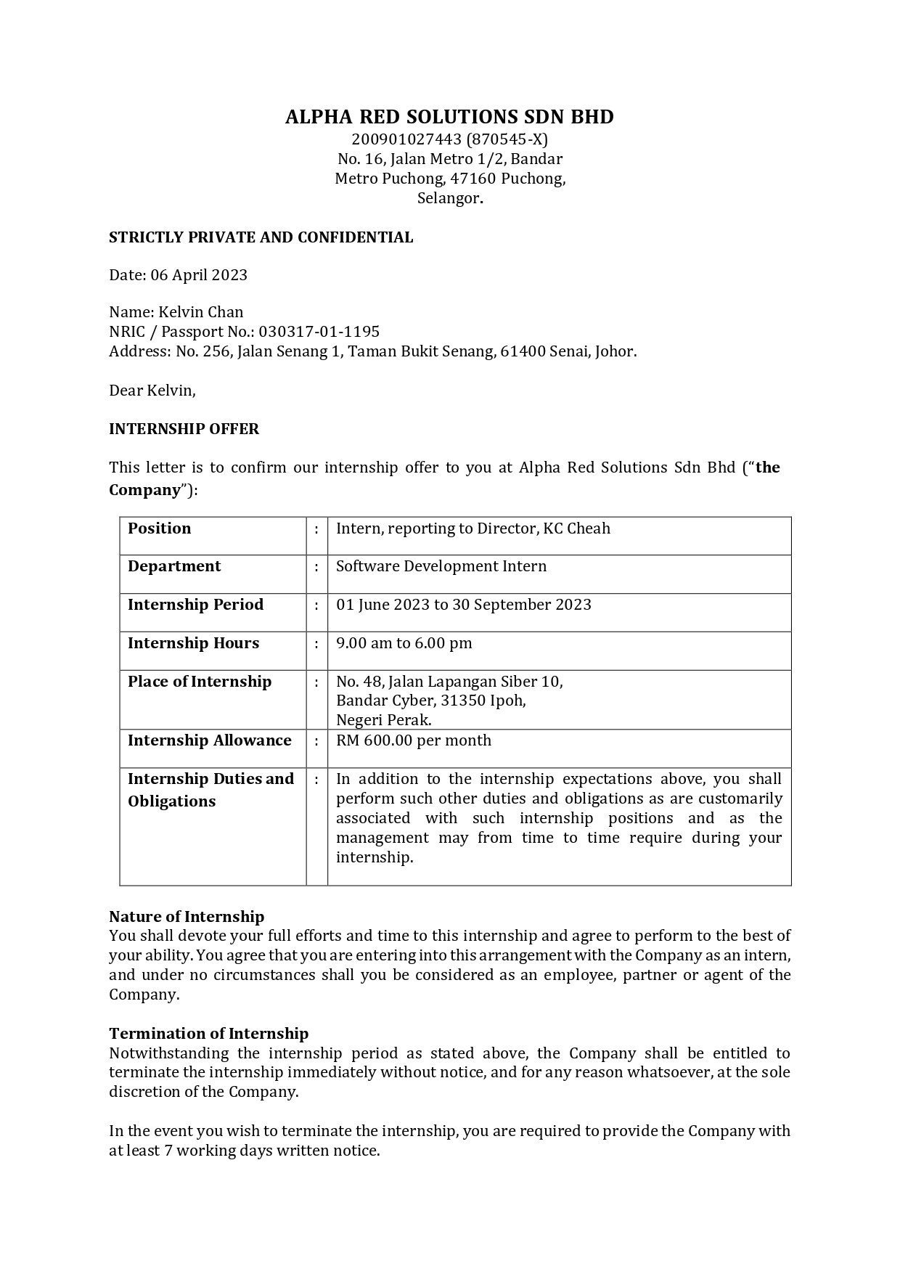





ABSTRACT

Industrial training is an essential component of many academic programs that provide students with practical experience in real-world workplace environments. The industrial training report serves as a summary and reflection of the skills, knowledge, and competencies acquired during the training period. The report aims to showcase the student's practical experience, including any challenges encountered and how they were addressed. The industrial training place is the organization or company where a student completes their practical training. The selection of the place is typically guided by the student's area of study or career aspirations. The place can be in the private or public sector and provides students with hands-on experience and exposure to real-world workplace environments. The industrial training period is the duration of time during which a student undertakes practical training in an industrial setting. During the four-month industrial training period, students can develop a range of practical skills, knowledge, and competencies relevant to their academic program and career aspirations. Beside that is also help students gain practical experience, develop professional skills and prepare them for their future careers.They can work on real-world projects, collaborate with industry professionals, and gain exposure to the latest technologies and industry trends.

ACKNOWLEDGEMENTS

I would like to express my deepest appreciation to the management of Alpha Red Solutions for giving me the opportunity to undergo industrial training at the company for 4 months.

My internship would not have been possible without the contribution and collaboration of others. Mr.Cheong Nan Feng, who is the company Manager and my supervisor while undergoing industrial training at Alpha Red Solutions. I want to thank him for giving me the opportunity to follow my internship at his company. He had the kindness to accept me in his company and guide me through my internship with advice and feedback despite his busy schedule.

To the rest of the Alpha Red Solutions staff for their support and guidance which helped me to overcome the challenges I faced during my internship training period.

Last but not least, special thanks to my parents who have given me encouragement and support to complete the 4 months of industrial training.

TABLE OF CONTENTS

CHAPTER DESCRIPTIONS PAGES

ABSTRACT i
ACKNOWLEDGEMENTS ii
TABLE OF CONTENTS iii
- INDUSTRIAL TRAINING
  - INTRODUCTION OF INDUSTRIAL TRAINING 1-2
  - OBJECTIVES OF INDUSTRIAL TRAINING 3
  - WORK SCOPE DURING INDUSTRIAL 4
TRAINING
- INDUSTRIAL TRAINING COMPANY BACKGROUND
  - COMPANY BACKGROUND 5 - 7
  - COMPANY VISION AND MISSION 8
  - JOB SCOPE IN COMPANY 9 - 12
  - COMPANY ORGANIZATION CHART 13
- INDUSTRIAL TRAINING ACTIVITIES
  - SUMMARY OF WEEKLY ACTIVITIES 14 - 16
  - SUMMARY OF WORK SCOPE 17
  - CHALLENGE AND SOLUTION 18

TABLE OF CONTENTS

CHAPTER DESCRIPTIONS PAGES

- CASE STUDY

  - CASE STUDY OF (TITLE) 19 - 21

  - PROBLEM-SOLVING DIAGRAM 22 - 24

CONCLUSION AND RECOMMENDATION

  - CONCLUSION 25

  - RECOMMENDATION 26 - 27

  - INDUSTRIAL TRAINING IMPACT TRAINER 28 - 30

APPENDIX REFERENCES

LIST OF ABBREVIATIONS

NOSS | NATIONAL OCCUPATIONAL SKILLS STANDARD
PP | PEGAWAI PENILAI
PPL | PEGAWAI PENGESAH LUARAN
PSD | PHOTOSHOP DATA FILE
JPEG | JOINT PHOTOGRAPHIC EXPERTS GROUP
PNG | PORTABLE NETWORK GRAPHICS
AI | ADOBE ILLUSTRATOR
WIX | WINDOWS INSTALLER (XML)
CC | CREATIVE CLOUD
GHz | GIGAHERTZ
MB | MEGABYTE
GB | GIGABYTE
DDR | DOUBLE DATA RATE
MHz | MEGAHERTZ
SSD | SOLID-STATE DRIVE
TB | TERABYTE
CMYK | CYAN, MAGENTA, YELLOW, AND KEY
GSM | GRAMS PER SQUARE METER
MM | MILLIMETERS
PT | POINTS
G | GRAM
DPI | DOTS PER INCH

LIST OF FLOWCHART

TABLES DESCRIPTIONS PAGES

TABLE 1 | COMPANY ORGANIZATION CHART | 13
TABLE 2 | PROBLEM-SOLVING DIAGRAM | 22

LIST OF FIGURE

FIGURES DESCRIPTIONS PAGES

FIGURE 1 | GOOD AND WELL COMPANY LOGO | 5
FIGURE 2 | GOOD AND WELL COMPANY | 6
FIGURE 3 | COMPANY ADDRESS AND LOCATION MAP | 7

LIST OF APPENDIX

Appendix No DESCRIPTIONS Appendix 1 Banner for social media advertisement Appendix 2
Appendix 3

CHAPTER 1 INDUSTRIAL TRAINING

INTRODUCTION OF INDUSTRIAL TRAINING

My industrial training period 1 June 2023 until 30 September 2023 my internship’s company name was Alpha Red Solutions. I was a Software Engine of Alpha Red Solutions department. During the internship period, my primary responsibilities involved tasks assigned by supervisors and colleagues. These tasks included writing new web developments, revising existing web designs, performing basic API handling, and managing data.

During the first week of my internship, my supervisor provided me with a set of materials and an outline for self-study, which allowed me to adapt more effectively to the tasks they had assigned me. These tasks included becoming proficient with tools like Git, Vue.js, Nuxt.js, and Tailwind CSS. Simultaneously, my supervisor patiently introduced me to the company's policies and environment. They also included me in Azure DevOps, granting me access to their development environment, setup, branches, and project resources, which further facilitated my onboarding process.

During the four months of my internship, I had the opportunity to learn programming languages that I hadn't studied before, such as Vue.js, Nuxt.js, and Tailwind CSS, along with more in-depth techniques within them. I also gained more chances to work and learn alongside experienced professionals.

At the beginning, I used to spend a long time on many simple tasks, such as converting all the HTML code to Nuxt.js and setting up mobile responsiveness, etc. With patience and guidance from my colleagues and superiors, I gradually adapted to it. Slowly, my understanding of Vue and Nuxt's language became even deeper than what I had learned in PHP before.
.

OBJECTIVES OF INDUSTRIAL TRAINING

The aims of Industry training is :
- Exposing trainees to the real world of work field specialization.
- Improve the knowledge and skills of the latest technology as well as the trainee's experience with the organization.
- Cultivate discipline, responsibility, teamwork and self-confidence.
- Expose trainees to safety practices and regulations at industry.
- Build collaboration between PB and industry
- Give opportunities to trainees to apply knowledge knowledge and performance learned and exposed technology and work practices in their respective fields of specialization.

WORK SCOPE DURING INDUSTRIAL TRAINING

The scope of work during industrial training can vary depending on the industry, company, and position of the trainee. However, here are some examples of work scopes that can be expected during industrial training:

- Learning the company's organizational structure, policies, and procedures
- Shadowing and assisting experienced staff members with their tasks
- Performing basic tasks related to the industry or position, such as data entry, inventory management, or customer service
- Conducting research or assisting with projects assigned by superiors
- Participating in training programs and workshops offered by the company
- Attending meetings and observing how they are conducted
- Learning about the safety regulations and procedures in the workplace
- Assisting with the maintenance and operation of equipment
- Learning about the company's products or services and how they are marketed
- Observing and learning about the company's production processes.

Overall, the scope of work during industrial training is to provide the trainee with hands-on experience in the industry and a better understanding of the company's operations.

CHAPTER 2
INDUSTRIAL TRAINING COMPANY BACKGROUND

COMPANY BACKGROUND

ALPHA RED SOLUTIONS SDN BHD located in Perak is a team of passionate technology enthusiasts dedicated to providing innovative and breakthrough IT solutions. We are committed to meeting our customers' technology needs and strive to deliver the best solutions for them. Whether it's in information technology, network solutions, or any other field, we aim for excellence and create exceptional value for our customers.:-

    - SYSTEM DESIGN & DEVELOPMENT
    - Meeting customer's web requirements
    - Upgrading and enhancing web design

ALPHA RED SOLUTIONS SDN BHD, motto & values:

    - Alpha Red Solutions are technology enthusiasts dedicated to innovative and breakthrough IT solutions.
    - Meeting our customers' technology needs with exceptional service and competitive pricing is our commitment.


Figure 1: Alpha Red Solutions Company Logo

2.1 a) Company Profile

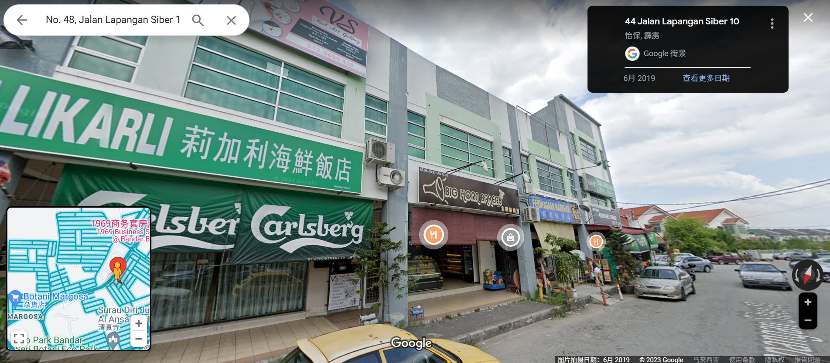

Figure 2 : Good And Well Company

Company Name : Alpha Red Solutions

Address : No. 48, Jalan Lapangan Siber 10, Bandar Cyber, 31350 Ipoh, Negeri Perak

Telephone No. : 017-4376550

Company Registration No. :

Email Website
: nfcheong@alphareds.com
: https://www.alphareds.com/

b) Company Address And Location Map

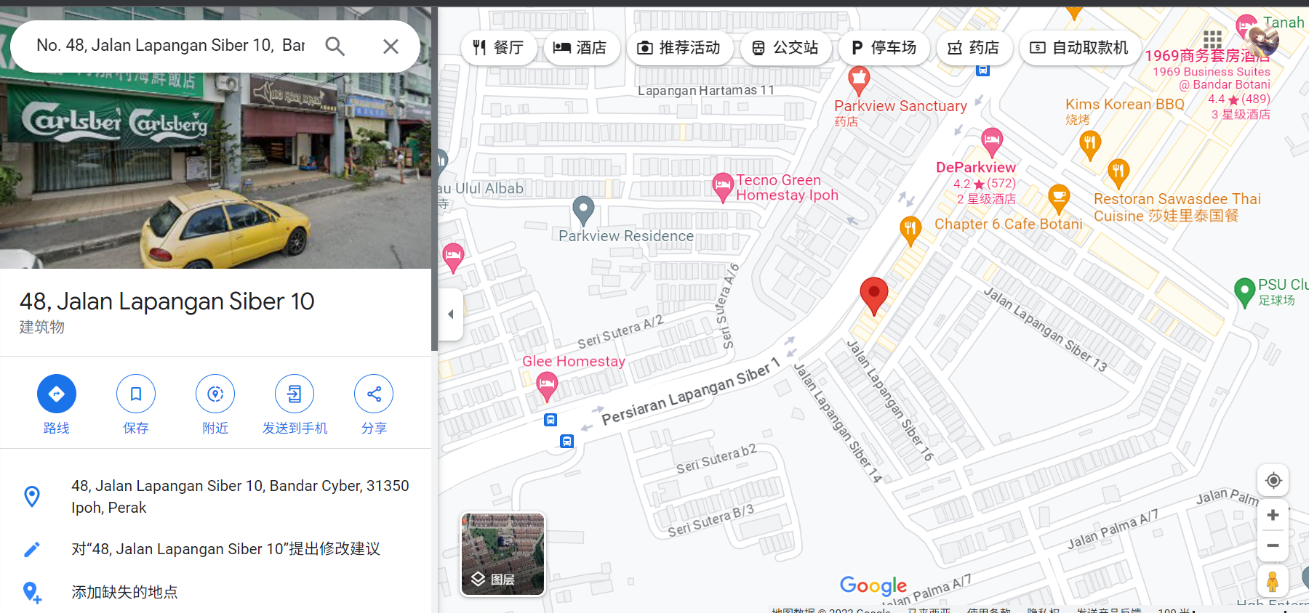

Figure 3 : Company Address And Location Map

Alpha Red Solutions
48, Jalan Lapangan Siber 10, Bandar Cyber, 31350 Ipoh, Perak,Malaysia.
Phone: 0174376550
Email: kccheah@alphareds.com

COMPANY VISION AND MISSION

The Company's vision and mission statements as below :

- Vision Statement:
To be a global leader in providing innovative and sustainable solutions for our customers, employees, and stakeholders.

- Mission Statement:
Our mission is to provide our clients with high-quality programming products and services that exceed their expectations, while fostering a safe and inclusive work environment that promotes teamwork, creativity, and individual technical growth. We are committed to operating with integrity, minimizing our technological footprint, and contributing to the programming community in which we operate.

WORK ACTIVITIES IN COMPANY
(NEED TO DESCRIBE AT LEAST 3 or 4 WORK ACTIVITIES PERFORMED IN INDUSTRIAL TRAINING WITH EXAMPLE TASK / PLEASE REFER BASED ON WORK ACTIVITIES PAGE NUMBER 15-26 AND XI - XXII)

- Illustrate text and typography

The work activities that I has been done in company was illustrate text and typography.

For example my first task involved performing UI design, such as transitioning the web page's code from HTML to Vue.js.

To complete this task, i might approach it in the following steps:

- Researching the target audience and drawing inspiration from other successful websites as a reference for UI design.

- Sketching initial ideas for the UI design, considering different font styles and text arrangements to ensure the visual appeal of UI design.

- Experimenting with different color schemes and graphic elements to complement the text and typography, ensuring the overall look of UI design was visually cohesive.

- Refining the design and selecting the most appealing logo concept for further development of UI design.

- Use design software to create a digital version of the logo, adding any final touches or adjustments as needed.

- Present the final design to the client and incorporate any feedback or revisions.

Through creative and effective text and typography design, you can help a website stand out and convey its message to customers.
- Prepare content write-up

The work activities of preparing a content write-up involve researching other websites and Nuxt.js. I will be writing a blog post about this topic and sharing it on social media.

To complete this task, I approach it in the following steps:

- Research other websites and gather information from reliable sources, including case studies, Nuxt.js experts, and personal experiences with web development.
- Organize your research into an outline or mind map, breaking down the key aspects you want to cover when working with other websites and Nuxt.js.
- Create a captivating and accurate title that reflects the topic related to other websites and Nuxt.js, while also grabbing the reader's attention.
- Generate content about other websites and Nuxt.js using a clear and engaging writing style to attract the intended audience.
- Incorporate relevant images, videos, or infographics to support and enhance the content about other websites and Nuxt.js.
- Edit and proofread your content, checking for grammar, spelling, and punctuation errors to ensure a smooth and logical flow of information when discussing other websites and Nuxt.js.
- Publish the blog post on the desired platform, such as a personal blog or a company website, and promote it through social media and other channels to reach a wider audience.

By preparing a well-researched and informative content write-up related to Nuxt and Vue, you can educate and inspire your readers while establishing your own credibility as a knowledgeable and engaging writer.

COMPANY ORGANIZATION CHART

COMPANY CHART

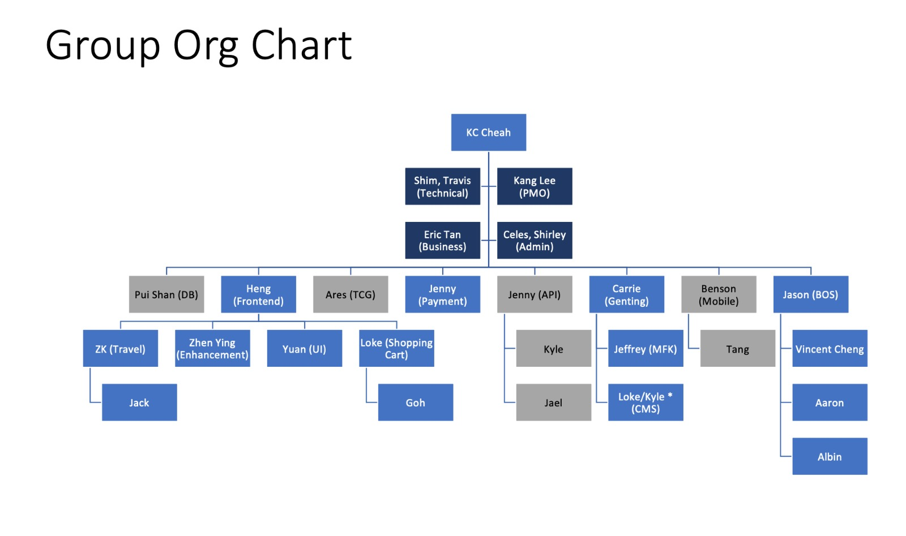

Table 1 : Company Organization Chart

CHAPTER 3 INDUSTRIAL TRAINING ACTIVITIES

SUMMARY OF WEEKLY ACTIVITIES

WEEK 1 (01 June 2023 – 2 June 2023) ACTIVITIES DONE DURING THIS WEEK
    - Study Nuxt.js and Vue.js
    - Study Tailwindcss

WEEK 2 (06 June 2023 - 9 June 2023) ACTIVITIES DONE DURING THIS WEEK
- Study Git and Branch

WEEK 3 (13 June 2023 - 17 June 2023) ACTIVITIES DONE DURING THIS WEEK
- Design customer about us interface

WEEK 4 (20 June 2023 - 23 June 2023) ACTIVITIES DONE DURING THIS WEEK
- Design social media- Facebook, Instagram, Whatsapp and Gmail

WEEK 5 (26 June 2023 - 30 June 2023) ACTIVITIES DONE DURING THIS WEEK
1. Generate strapi data

WEEK 6 (03 July 2023 - 07 July 2023) ACTIVITIES DONE DURING THIS WEEK
1. Design Strapi data

WEEK 7 (10 July 2023 - 14 July 2023) ACTIVITIES DONE DURING THIS WEEK
1. Design Strapi data

WEEK 8 (17 July 2023 - 21 July 2023) ACTIVITIES DONE DURING THIS WEEK
- Fetching Strapi data
- Design customer about us interface

WEEK 9 (24 July 2023 - 28 July 2023) ACTIVITIES DONE DURING THIS WEEK
- Create Register Page
- Integrating Api

WEEK 10 (31 July 2023 - 04 August 2023) ACTIVITIES DONE DURING THIS WEEK
- Fetching Register Page Api

WEEK 11 (07 August 2023 - 11 August 2023) ACTIVITIES DONE DURING THIS WEEK
- Create Profile Page

WEEK 12 (14 August 2023 - 18 August 2023) ACTIVITIES DONE DURING THIS WEEK
- Settting Up Api for Profile Page

WEEK 13 (21 August 2023 - 25 August 2023) ACTIVITIES DONE DURING THIS WEEK
- Create Login Page
- Connect Api for Login Page

WEEK 14 (28 August 2023 - 01 September 2023) ACTIVITIES DONE DURING THIS WEEK
- Design Privacy Policy Page
- Design customer Contact Us Page

WEEK 15 (04 September 2023 - 08 September 2023 ) ACTIVITIES DONE DURING THIS WEEK
- Change Home Page design

WEEK 16 (11 September 2023 - 15 September 2023 ) ACTIVITIES DONE DURING THIS WEEK
- Create Pop Up Message for all page
- Change Some design for register page

WEEK 17 (18 September 2023 - 22 September 2023 ) ACTIVITIES DONE DURING THIS WEEK
- Create Google Recaptha
- Design hotelDetail interface

WEEK 18 (25 September 2023 - 27 September 2023 ) ACTIVITIES DONE DURING THIS WEEK
1. Design UI Interface for hotel page

SUMMARY OF WORK SCOPE

As a part of my Diploma studies in Creative Content Development I did a 4 months internship (1st Jun 2023 – 30th September 2023) at the ALPHA RED SOLUTIONS that was established in 2009 consists of reputable IT and Corporate Strategy management executives from the aviation industry with extensive real-life experience in the airline, eCommerce, hospitality, transportation, finance, and payment industries. I completed the industry training perfectly within the period, as well as preparing my industry reports. It helps me to know and discover myself from different angle.

As an intern web designer, my responsibilities included UI design, configuring some APIs, and handling data. I also collaborated with team members to complete various tasks related to UI design, API integration, and Strapi data management. Essentially, my role involved completing the tasks assigned by the supervisor and pushing them for the supervisor to upload to the cloud.

In summary of my internship experience with ALPHA RED SOLUTIONS, I successfully improved my skills, and I found that this period of internship significantly enhanced my programming abilities. Despite the challenges throughout this time, I believe it was highly valuable for my growth. For instance, I learned new programming languages such as Vue.js, Tailwind CSS, and Nuxt.js.

CHALLENGE AND SOLUTION

One of the biggest challenges I faced during my industrial training was adapting to the fast-paced and dynamic nature of the workplace. However, I was able to overcome this challenge by actively seeking out feedback from my supervisor, taking on additional responsibilities to expand my skill set, and consistently prioritizing and managing my workload to meet project deadlines.

During my internship, I encountered some challenges while designing web pages, including not knowing how to use Tailwind CSS to make certain design changes, handling APIs and server issues, and dealing with certain Nuxt.js script functions. Typically, in such situations, I would seek guidance from my supervisor and other experienced colleagues, asking them to teach me how to address these issues. Through their guidance, I was able to overcome these challenges.

In addition, I also faced some other challenges: due to my limited proficiency in English, I encountered some communication issues with team members and my supervisor. Nevertheless, I made an effort to communicate with them in English until the project deadlines. I improved my communication skills by consistently engaging in communication and feedback with team members, completing my tasks in a timely manner, and continuously communicating with team members to resolve issues. I also sought help from experienced colleagues and efficiently foundsolutions.

CHAPTER 4 CASE STUDY

4.1 CASE STUDY OF TROUBLESHOOT A MALFUNCTIONING CIRCUIT

For Case study that I have face in my On job Training at Alpha Red Solutions is related to work activities (WA) level 4 cocu 5.

I need to create a UI design using Nuxt.js and Tailwind CSS that closely follows the design provided by the client. It's essential to match the client's design as closely as possible to satisfy both my client and my superiors. However, there may be some deviations during my work, so I will need to make continuous adjustments.I need to create a UI design using Nuxt.js and Tailwind CSS that closely follows the design provided by the client. It's essential to match the client's design as closely as possible to satisfy both my client and my superiors. However, there may be some deviations during my work, so I will need to make continuous adjustments.

The issue is that even if I make changes following the original design, there are still slight deviations. Even though I couldn't see any issues, my supervisor noticed some discrepancies and provided me with examples for making adjustments.

The issue is that even if I make changes following the original design, there are still slight deviations. Even though I couldn't see any issues, my supervisor noticed some differences and provided me with examples to make adjustments. If I couldn't resolve those issues after several hours, my supervisor would schedule a meeting with me to personally teach me how to solve them, or he would arrange for more experienced colleagues to assist me. After some time and with their guidance, I was finally able to resolve those issues and learn how to address them if they arise in the future.

CASE STUDY OF DEVELOPING A NEW PRODUCT FOR A CLIENT REQUIREMENTS

For Case study that I have face in my On job Training at ALPHA RED SOLUTIONS SDN BHD is related to work activities (WA) level 4 COCU 5

In my team, I was assigned the task of creating a UI interface for a webpage design provided by the client using Nuxt.js and Tailwind CSS. This also involved replacing all the HTML code provided by my supervisor with Tailwind CSS and Nuxt.js.

The problem is that both my teammates and I are interns, so we have limited experience, making it challenging to strike a balance between the client's requirements and the technical constraints of the project. The team is also working hard to generate new ideas and creative solutions to meet the client's needs.

To overcome the problem, the design team took the following steps:

Conducted research - The team conducted extensive research on similar products in the market, existing technologies, and industry trends. This research helped the team understand design constraints and identify potential design solutions.

Brainstorming sessions - The team held brainstorming sessions to generate new ideas and approaches for the project. During these sessions, the team discussed various design options, their advantages and disadvantages, and evaluated their feasibility.

Prototyping and testing - The team developed several prototypes based on the most promising design solutions. These prototypes were tested in real-life scenarios to assess their functionality and performance.

Collaboration with the client - The team collaborated with the client throughout the design process to ensure that their requirements were met. The team shared their progress and ideas with the client regularly and incorporated their feedback into the design.

The result was a successful design that met all the client's requirements, was technologically feasible, and innovative.

This case study demonstrates that designing a product based on a client's requirements can be challenging, especially when the design team has limited experience in the industry. In such cases, it is essential to conduct thorough research, brainstorm new ideas, prototype and test designs, and collaborate closely with the client to ensure that their needs are met. With careful planning and a structured approach, it is possible to design innovative products that meet client requirements while being feasible from a technical standpoint.

** NOTE : (THE TRAINEE NEEDS TO IDENTIFY AN ACTIVITY INVOLVING WORK ACTIVITIES AND BRIEFLY EXPLAIN THE ROLE OF THE TRAINEE IN THE ACTIVITY, ATTACH A FLOW CHART, PICTURES AND ANY DOCUMENTS IN THE APPENDIX )

  - PROBLEM-SOLVING DIAGRAM

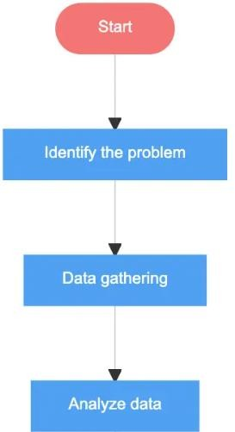
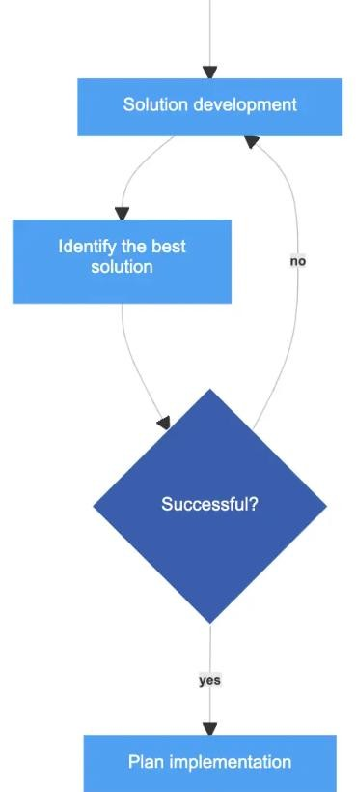
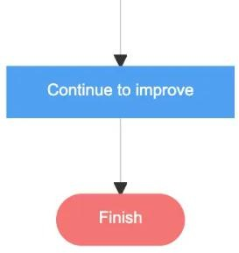

Table 2 : Problem-Solving diagram

A flowchart is a type of diagram that shows a step-by-step view of a process. Flowcharts document the tasks and decisions needed to achieve a specific goal. A basic flowchart is easy to make and understand. Based on the flowcharts above, can help to identify problem this can help me in solving problems and in the same time can come up with thoughtful ideas.

The flowchart processes are as below :

Start with identify the problem
This is the starting point of the process, where the problem or issue is identified and added to a queue or list for further analysis.

Identify the problem with data gathering
The problem is identified and clearly defined to ensure everyone understands the issue at hand.

Data gathering by analyze data
Relevant data is collected to better understand the problem and its root causes. This can involve talking to stakeholders, analyzing metrics, conducting surveys, and other data collection methods.

Analyze data found the solution development
The data collected is analyzed to gain insights into the problem and identify potential solutions.

Solution development can identify the best solution
Based on the analysis of the data, potential solutions are developed and evaluated.

Identify the best solution
The potential solutions are evaluated, and the best solution is identified based on criteria such as feasibility, impact, and cost-effectiveness.

If no successful will continue with solution development

If successful was yes will continue to plan implementation
Once the best solution has been identified, a plan is developed for implementing the solution.

Plan implementation is continue to improve
After the solution has been implemented, the process of continuous improvement begins. Data is collected to monitor the effectiveness of the solution, and adjustments are made as needed.

Continue to improve until final (Finish)
The process concludes when the problem has been effectively addressed and resolved, or when it has been determined that the problem cannot be solved at this time.

CHAPTER 5 CONCLUSION AND RECOMMENDATION

  - CONCLUSION

Industrial training is very challenging and must have self confidence. It because in ALPHA RED SOLUTIONS SDN BHD, cooperate very important in doing job. From there I learn how to design efficiently and how to interact with customer. Thus, I can add knowledge from less what I have known. For example a new programming language and well-designed UI. Industrial training can teach me how to work differently and learn more skill and designing.I learn the different methods and approaches of dealing with and solving design problems.The ALPHA RED SOLUTIONS SDN BHD, is a good place to do the internship since it provides numerous benefits and advantages to the practical trainees.

In conclusion, industrial training is an essential component of any academic program that aims to prepare students for the professional world. Through this training, students can gain valuable real-world experience, develop essential technical and soft skills, and build their professional networks.

During industrial training, students have the opportunity to apply their theoretical knowledge to practical projects and tasks, work alongside experienced professionals, and learn about the inner workings of a particular industry or organization. This hands-on experience can help students gain a deeper understanding of the industry and its challenges, as well as develop a sense of purpose and direction for their future career paths.

Furthermore, industrial training can provide students with valuable feedback, mentorship, and guidance from professionals in their field, which can help them identify their strengths and areas for improvement. By reflecting on their experiences and taking the feedback they receive to heart, students can gain a better understanding of their own professional goals and how to achieve them.
Overall, industrial training is a valuable opportunity for students to bridge the gap between academia and the professional world, and to gain the skills and knowledge they need to succeed in their chosen careers.

PROBLEMS FOUND AND PROPOSED SOLUTIONS

While industrial training can be beneficial for both the student , there are also some common problems that may arise during the training program. Here are some examples of problems that can be encountered during industrial training:

Limited exposure: The training program may not provide the student with a broad enough range of experiences and may limit their exposure to different aspects of the industry.

Inadequate supervision: The student may not receive enough supervision or guidance from the trainer, which can result in a lack of direction and development.

Inadequate training resources: The training program may not have sufficient resources, tools, or equipment to provide a comprehensive learning experience.

Mismatched expectations: The student's expectations of the training program may not match the actual experience, leading to dissatisfaction and a lack of engagement.

Communication issues: Poor communication between the student, the trainer, and the organization can lead to misunderstandings and problems with the training program.

Lack of feedback: The student may not receive adequate feedback from the trainer, which can hinder their development and progress.

Inadequate evaluation: The training program may not have an effective evaluation system in place, making it difficult to assess the student's performance and progress.

Cultural or organizational differences: The student may encounter cultural or organizational differences that can make it challenging to adapt and perform effectively.

Four common problems and solution recommendations that can be found in industrial training:

Problem 1: Lack of hands-on experience and practical skills development.
Solution Recommendation: Provide opportunities for students to work on real-world projects and simulations, offer training on industry-specific tools and equipment, and incorporate practical assessments and evaluations.

Problem 2: Limited industry exposure and networking opportunities.
Solution Recommendation: Establish partnerships with industry partners to offer students access to internships, apprenticeships, and mentor ship opportunities. Host industry events and guest speakers to increase networking opportunities.

Problem 3: Insufficient feedback and evaluation Solution Recommendation: Provide regular feedback and evaluations to students to help them track their progress and identify areas for improvement. Offer personalized coaching and mentoring to help students achieve their goals.

Problem 4: Mismatch between student skills and industry demands Solution Recommendation: Conduct skills assessments to identify gaps and offer targeted training programs to bridge those gaps. Collaborate with industry partners to ensure that training programs are aligned with current industry needs and trends.

INDUSTRIAL TRAINING IMPACT TO TRAINER

Industrial training can have a significant impact on the trainer, who is the professional or experienced individual responsible for supervising and mentoring the student during their industrial training program. Here are some ways that industrial training can impact the trainer:

Develops leadership and coaching skills: The trainer has the responsibility to guide, coach, and mentor the student during the training program. This can help develop their leadership and coaching skills, which can be useful in their future professional endeavors.

Facilitates knowledge transfer: By sharing their expertise and knowledge with the student, the trainer can contribute to the development of the next generation of skilled professionals in their field.

Provides networking opportunities: Working closely with students during their training program can create networking opportunities for the trainer, as they can establish professional connections with the students and potentially recruit them as employees in the future.

Increases job satisfaction: Serving as a trainer can be a fulfilling experience, as it allows the trainer to contribute to the growth and development of the next generation of professionals in their field. This can lead to increased job satisfaction and a sense of purpose.

Enhances professional reputation: By serving as a trainer, the professional can enhance their professional reputation and credibility within their industry, as they are recognized for their expertise and their willingness to give back by training and mentoring the next generation of professionals.

Industrial training can have a positive impact on the trainer, both in terms of their professional development and their personal fulfillment.

Skill Development: Industrial training provides trainers with an opportunity to develop and hone their skills. They can refine their training techniques, gain experience in different training methodologies, and acquire new skills that can be applied to their future teaching practices.

Networking: Trainers who conduct industrial training are often able to establish connections with industry professionals and organizations. This networking can provide opportunities for career advancement, collaboration on future projects, and access to new resources and tools.

Personal Growth: Industrial training can help trainers to develop new perspectives and broaden their understanding of the industry. They can gain exposure to new ideas and approaches, and learn from the experiences of their trainees. This can lead to personal growth and a deeper sense of fulfillment in their profession.

In the some ways that industrial training can have a positive impact on the trainer :

Skill development: As a trainer, the professional has the opportunity to further develop their own skills, knowledge, and expertise through teaching and mentoring others. This can improve their own abilities and make them more valuable to their organization or industry.

Increased job satisfaction: Many trainers find the experience of working with students and contributing to their development to be highly rewarding, which can lead to increased job satisfaction and motivation.

Personal and professional growth: Serving as a trainer can also lead to personal and professional growth for the trainer, as they develop new perspectives, learn from their students, and gain a deeper understanding of their own field.

Enhanced reputation: Being a trainer can enhance the professional reputation of the individual within their organization and industry, as they are recognized for their contributions to developing the next generation of professionals.

Networking opportunities: Trainers have the opportunity to build relationships and networks with students and other professionals in their field, which can lead to new opportunities and collaborations.

Recruitment potential: Trainers may identify talented students during their training program and potentially recruit them as future employees, which can be beneficial for the organization as well as the trainer.

Overall, industrial training can have many positive impacts on the trainer, both in terms of their personal and professional development, as well as the potential benefits to their organization and industry.

** Chapter 1 - 5 : 20 - 30 pages (exclude picture and appendix)

REFERENCES

Artical from the journal:
Mohd Mustafa Al Bakri Abdullah dan rakan-rakan (2007), Kajian Keberkesanan Promosi Universiti Malaysia Perlis, Jurnal HEPA, UMP.

Norhayati Othman & Intan Junizah Abu Samah (2014), Pengaruh Pemilihan Pengajian ke KolejKomuniti dan Cadangan Promosi, Kolej Komuniti Selayang.

Norziha Jusoh (2006), Kajian Mengenai Faktor-faktor Pemilihan Pelajar Matrikulasi keUniversiti Tempatan (IPTA) dan Kursus Pendidikan, Tesis Sarjana UTM.

Artical from internet:
Vizcaya-Moreno & Pérez-Cañaveras (2020), Media Technology In The Education Sector, New York.
Orús et al (2016) , YouTube Website For Communication Purposes, New York. Moghavvemi et al. (2018), YouTube records, Finland
Foster (2020) , YouTube website has become very popular, Kenya Barzola et al., (2019), YouTubesite for sharing information and material,
Netherlands
Dom Hennequin, How to cretae a video : the ultimate guide to video production, Ecuador
Sulistianingsih and Mukminan (2019), Proceedings of the 3rd International Conference on Current Issues in Education, ICCIE.
Roodt and Peier (2013), YouTube as an academic tool for ICT lectures, University of Cape Town, South Africa.
Dom Hennequin, How to cretae a video : the ultimate guide to video production

*** CONTOH PENULISAN BAGI RUJUKAN / REFERENCES :
